Ga vacancies in GaN: challenge for theorists and experimentalists
František Hájek^{1,2}, Filip Dominec¹, Alice Hospodková¹, Tomáš Hubáček¹, Karla Kuldová¹, Jiří Oswald¹, Jiří Pangrác¹, Jakub Čížek³
¹Institute of Physics of the Czech Academy of Sciences, v.v.i., Cukrovarnická 10, 162 00, Prague 6, Czech Republic
²Czech Technical University in Prague, Faculty of Nuclear Sciences and Physical Engineering, Břehová 7, 115 19, Prague 1, Czech Republic
³Faculty of Mathematics and Physics, Charles University, V Holešovičkách 2, 18000, Praha 8, Czech Republic
hajekfr1@fjfi.cvut.cz

Abstract
Despite large spread of GaN-based devices in 1990s, several fundamental questions about GaN properties remain unanswered. One of them is a role or even a presence of Ga vacancies in GaN. According to the first-principle calculations, the Ga vacancy formation energy is too high for their presence in significant concentrations. However, this is in contradiction with experiments. In this work, new findings obtained by variable energy positron annihilation spectroscopy are shown and discussed.
Key words: Nitrides, Vacancies, Positron Annihilation Spectroscopy, Luminescence

Introduction
Optimization of methods for high-quality GaN growth in 1990s paved a way for power-efficient optoelectronic devices [1]. Nowadays, GaN based devices are used as LEDs, high electron mobility transistors or detectors [2]. Despite the extensive research on both application and basic properties of GaN and related materials in the past three decades, several fundamental questions remain unanswered. One of them is the role or even the presence of Ga vacancies in GaN.
There are many first-principle calculations predicting negligible concentration of Ga vacancies in GaN [3],[4]. The Ga vacancy is predicted to form multiple levels inside GaN bandgap with corresponding transition levels from (-2/-3) to (+/0). Preferred charge state and its formation energy depends on Fermi level position. It should be mentioned, that the first-principle calculations are performed in thermodynamic equilibrium at zero temperature.
Experimental techniques which might identify Ga vacancy include positron annihilation spectroscopy (PAS) (namely positron annihilation lifetime spectroscopy (PALS) and Doppler broadening positron annihilation spectroscopy) or electron paramagnetic resonance (EPR). Positron annihilation lifetime spectroscopy is based on the measurement the time between the creation of positron and its annihilation in the material with (valence) electrons. The annihilation is detected through the 511 keV photon which is created during the annihilation event [5]. The lifetime of the positron is increased in the case that positron is trapped in open volume in the material. These include surface, dislocations or vacancies. To identify the defect, first-principle positron lifetime calculation must be performed. The vacancy concentration is obtained from the count ratio between these trapped positrons there and free positrons in the material.
PALS was used to study bulk GaN material grown by hydride vapour epitaxy or ammonothermal technique in the past [6],[7]. The measurements revealed high concentration of Ga vacancies in order 10¹⁷ cm⁻³, much higher, than predicted by theory. However, it was not possible to measure GaN samples grown by the most common method for GaN growth, Metal Organic Vapour Phase Epitaxy (MOVPE) by standard PALS due to the small thickness of the MOVPE GaN samples and large penetration depth of positrons generated by conventional source ²²Na isotope. To overcome this problem, different source of positrons is needed. The synchrotron or linear accelerator with chopped beam can be used. The generated positrons can be moderated and accelerated to the required energy (and therefore, penetration depth) = variable energy positron annihilation spectroscopy (VEPAS). In this work, unique VEPAS data on MOVPE grown GaN samples are presented.

Experimental
GaN samples were grown on the Aixtron 3 × 2 CCS MOVPE system equipped with LayTec EpiCurveTT apparatus for in situ measurement of reflectivity, curvature and true wafer temperature. Sapphire substrates with c-plane orientation were used for the growths. Buffer layers were grown with trimethylgallium (TMGa) and ammonia precursors with a hydrogen carrier gas (sample STMGH). Additional details can be found elsewhere [8]. 1 μm thick GaN layers grown at different growth conditions were grown atop these GaN buffers (samples STEGH and STEGN) with triethylgallium (TEGa) precursor instead of TMGa one. List of samples with growth conditions are shown in Tab. 1. Si doping was used for n-type conductivity of the samples STEGH and STEGN.
Tab. 1: Samples studied by VEPAS.
Sample | Growth temperature (°C) | Precursor for Ga | Carrier gas | Si concentration (cm⁻³)
STMGH | 1052 | TMGa | H₂ | < 10¹⁶
STEGH | 950 | TEGa | H₂ | 10¹⁸
STEGN | 950 | TEGa | N₂ | 10¹⁸

The LINAC source of positrons in Helmholtz-Zentrum Dresden [9] was used in this study and the energy of positron was varied between 2 keV to 16 keV.
Photoluminescence (PL) measurements were carried out with confocal microscope LabRAM HR Evolution, He-Cd laser (wavelength 325 nm), objective 74CG, spot diameter 2 µm and CCD detector Synapse with UV enhanced sensitivity. Both excitation and emission light were passed through objective and reflected laser light was filtered by in-build edge filter. Wavelength 325 nm (=3.8 eV) enables excitation over GaN bandgap and the characteristic penetration depth is about 100 nm. Energy resolution is constant for all measurements and is about 0.1 nm.

Results and discussion
Spectra of positron lifetimes contain 3 components: lifetime of free positrons, trapped positrons and positronium. The last component is relevant only for the smallest penetration depth because it is connected to surface annihilation. Fig. 1 shows the lifetime of trapped and free positrons dependence on positron energy for sample STMGH. The positron energy is connected with the penetration depth z of positron and be approximated by [10]:
$$z= \frac{A}{ρ}E^{b}$$
where A = 4 μg/cm², $ρ$ = 6.15 g/cm³, and b = 1.6. Theoretical lifetimes of free positron in GaN and trapped positron in Ga vacancy are marked by pink and violet rectangles, respectively, in Fig. 1. The width of the rectangle on time scale represents the uncertainty of theoretical values from literature [11]. It is observed that at low positron energy, the lifetime of trapped positron is high, over 300 ps and it starts to fall to 220 ps at energies beyond 6 keV. This lifetime perfectly matches the calculated lifetime for positron trapped in Ga vacancy. The high values of the lifetime at low positron energies are affected by diffusion of positrons to the surface, where the lifetime of positrons is longer due to the smaller electron density. Therefore, to obtain relevant information about defects in the sample, energy larger than 10 keV must be used.
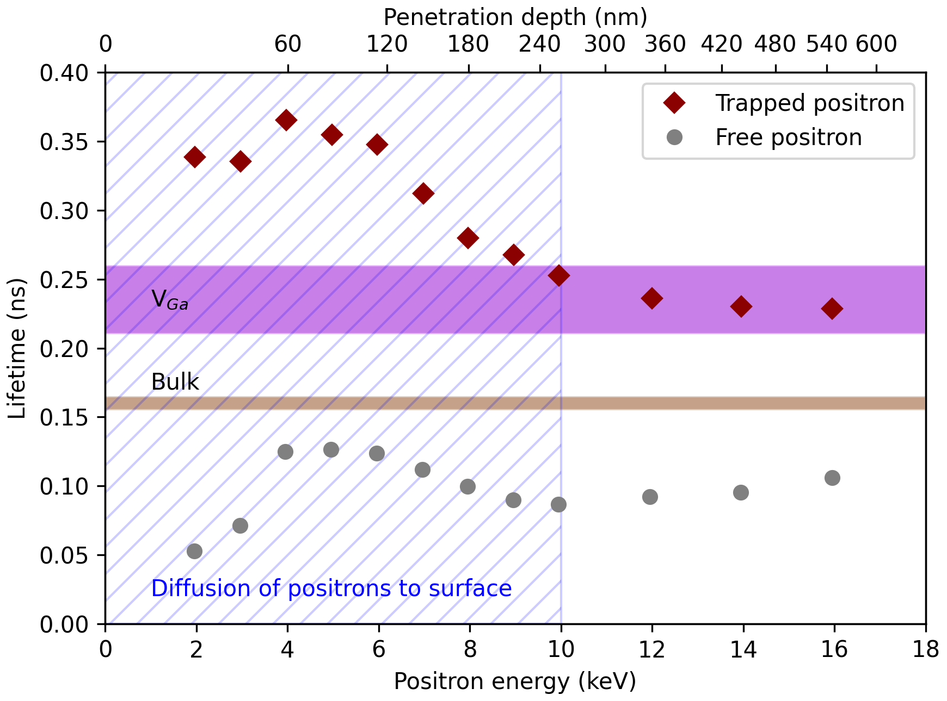
Figure 1: Positron lifetimes for free and trapped positron in sample STMGH. The hatched area represents the effective depth of diffusion to the surface for positrons. Theoretical values of lifetimes for free positrons and for those trapped in V_{Ga} are marked with rectangles.
Table 2 presents defects and their concentrations in the measured samples revealed by the VEPAS technique. Positrons trapped at clusters of vacancies (sample STEGN) have higher lifetimes than those trapped in Ga vacancies only because of the larger open volume of the clusters.
Tab. 2: Defects and their concentration obtained by VEPAS.
Sample | Defect type | Concentration (10¹⁷ cm⁻³)
STMGH | V_{Ga} | 1.1
STEGH | V_{Ga} | 1
STEGN | 3V_{Ga}+2V_{N} | 0.3

Photoluminescence spectra of the studied samples are plotted in Fig. 2. Three peaks can be observed: yellow band (YB) with maximum at 2.2 eV, weak blue band (BB) with maximum at 2.85 eV and GaN free exciton or band-to-band recombination peak at 3.41 eV. Higher intensity of GaN exciton in samples STEGH and STEGN is caused by Si doping (doping was not used in sample STMGH). The debate about origin of YB is still not definitively resolved. V_{Ga} with complexes with O_{N} or H are sometimes considered as the source of YB [12]. In our samples, concentration of V_{Ga} is almost the same in samples STMGH and STEGH, while the YB intensity differs by order of magnitude in the spectra of these two samples. This observation suggests that yellow band in these samples has different origin, most probably C_{N} [13].
Quite surprisingly, the highest excitonic luminescence has the sample STEGN which contains large vacancy clusters 3V_{Ga}+2V_{N}. This suggest that agglomeration of vacancies is beneficial for luminescence properties in the material. The presented results indicate that Ga vacancies act as non-radiative centers, as predicted by theorists [14].
However, it should be noted that VEPAS measurement cannot resolve the lifetime of positron trapped at bare V_{Ga} vacancy and positron trapped at complex V_{Ga}-H, V_{Ga}-2H or V_{Ga}-O_{N}, because the calculated changes of positron lifetime for these defects are below the measurement resolution limit. In fact, the formation energy for these complex defects is predicted to be much lower than for bare V_{Ga}. This might explain the observed discrepancies between observed “V_{Ga}” concentration and the concentration predicted by the theory.
Nevertheless, there are still open challenges for theorists. For example, first-principle calculations do not predict formation of different type of defects when the carrier gas is changed which observed experimentally (compare results on samples STEGH and STEGN). Thus, models beyond thermodynamic equilibrium and non-zero temperatures must be adopted in the future. The presented experiments prove that the kinetics of the chemical reactions during the GaN growth play important role in vacancy-type defect formation.
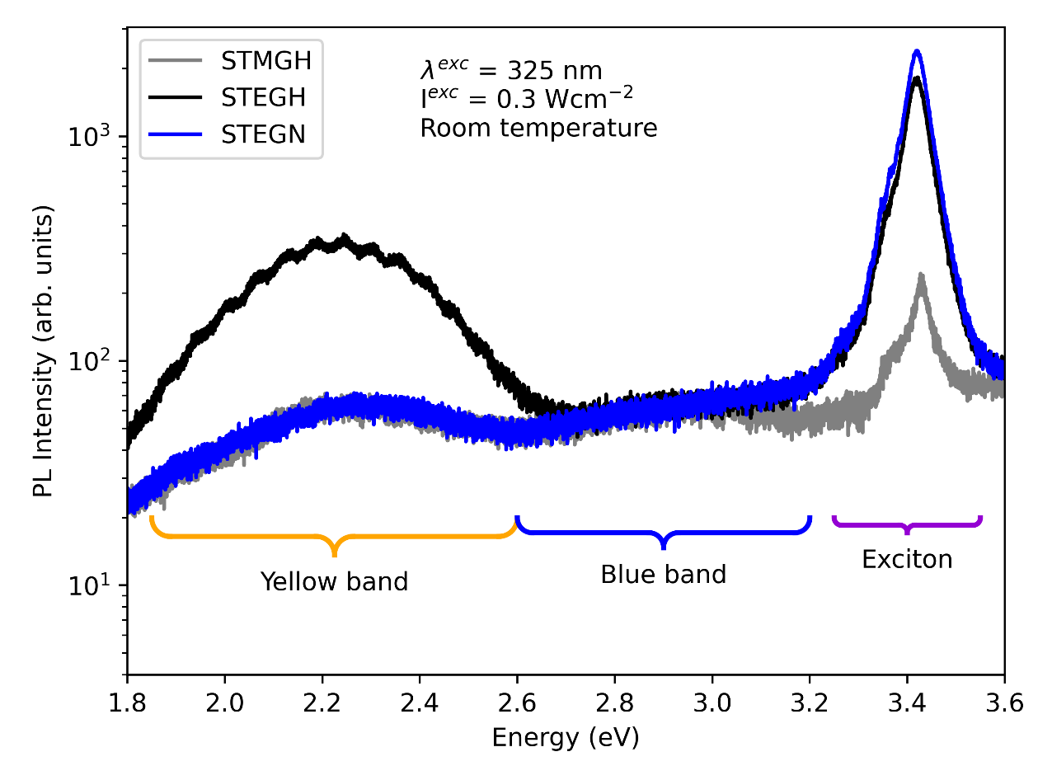
Figure 2: PL spectra of three samples with different vacancy-type defects and their concentrations.

Conclusion
Ga vacancy-type defects were observed by VEPAS technique on MOVPE grown GaN samples. It was shown that vacancies tend to form clusters when nitrogen as carrier gas is used. Next, from presented experiments, Ga vacancies seem not to be the origin of YB. Discrepancies between experimental observations and theory will require more complex models for future calculations of V_{Ga} formation.

References
[1] S. Nakamura, Nobel Lecture: Background story of the invention of efficient blue InGaN light emitting diodes, Rev. Mod. Phys. 87 (2015) 1139. https://doi.org/10.1103/REVMODPHYS.87.1139/FIGURES/17/MEDIUM.
[2] B. (Bernard) Gil, Low-dimensional nitride semiconductors, Oxford Univ. Press. (2000). https://global.oup.com/academic/product/low-dimensional-nitride-semiconductors-9780198509745?cc=gb&lang=en&# (accessed August 4, 2022).
[3] J.L. Lyons, C.G. Van De Walle, Computationally predicted energies and properties of defects in GaN, Npj Comput. Mater. 2017 31. 3 (2017) 1–10. https://doi.org/10.1038/s41524-017-0014-2.
[4] J. Neugebauer, C.G. Van de Walle, Gallium vacancies and the yellow luminescence in GaN, Appl. Phys. Lett. 69 (1998) 503. https://doi.org/10.1063/1.117767.
[5] R. Krause-Rehberg, H.S. Leipner, Positron Annihilation in Semiconductors, 127 (1999). https://doi.org/10.1007/978-3-662-03893-2.
[6] K. Saarinen, T. Laine, S. Kuisma, J. Nissila, P. Hautojarvi, L. Dobrzynski, J.M. Baranowski, K. Pakula, R. Stepniewski, M. Wojdak, A. Wysmolek, T. Suski, M. Leszczynski, I. Grzegory, S. Porowski, Observation Of Native Ga Vacancies In Gan By Positron Annihilation, MRS Online Proc. Libr. 482 (1997) 757–762. https://doi.org/10.1557/PROC-482-757.
[7] F. Tuomisto, T. Kuittinen, M. Zaja¸c, R. Doradziński, D. Wasik, Vacancy–hydrogen complexes in ammonothermal GaN, J. Cryst. Growth. 403 (2014) 114–118. https://doi.org/10.1016/J.JCRYSGRO.2014.06.005.
[8] T. Hubáček, A. Hospodková, J. Oswald, K. Kuldová, J. Pangrác, Improvement of luminescence properties of GaN buffer layer for fast nitride scintillator structures, J. Cryst. Growth. 464 (2017) 221–225. https://doi.org/10.1016/J.JCRYSGRO.2016.12.088.
[9] A. Wagner, Intense Positron Sources driven by a Superconducting Electron LINAC PSD20, 1.-5.3.2021, Mumbai, (n.d.). www.helmholtz.de (accessed September 8, 2022).
[10] M.J. Puska, R.M. Nieminen, Theory of positrons in solids and on solid surfaces, Rev. Mod. Phys. 66 (1994) 841. https://doi.org/10.1103/RevModPhys.66.841.
[11] K. Saarinen, J. Nissilä, J. Oila, V. Ranki, M. Hakala, M.J. Puska, P. Hautojärvi, J. Likonen, T. Suski, I. Grzegory, B. Lucznik, S. Porowski, Observation of Ga vacancies and negative ions in undoped and Mg-doped GaN bulk crystals, Phys. B Condens. Matter. 273–274 (1999) 33–38. https://doi.org/10.1016/S0921-4526(99)00400-7.
[12] J.L. Lyons, A. Alkauskas, A. Janotti, C.G. Van de Walle, First-principles theory of acceptors in nitride semiconductors, Phys. Status Solidi. 252 (2015) 900–908. https://doi.org/10.1002/PSSB.201552062.
[13] M.A. Reshchikov, M. Vorobiov, D.O. Demchenko, Ozgur, H. Morkoç, A. Lesnik, M.P. Hoffmann, F. Hörich, A. Dadgar, A. Strittmatter, Two charge states of the C N acceptor in GaN: Evidence from photoluminescence, Phys. Rev. B. 98 (2018) 125207. https://doi.org/10.1103/PHYSREVB.98.125207/FIGURES/17/MEDIUM.
[14] S.F. Chichibu, A. Uedono, K. Kojima, H. Ikeda, K. Fujito, S. Takashima, M. Edo, K. Ueno, S. Ishibashi, The origins and properties of intrinsic nonradiative recombination centers in wide bandgap GaN and AlGaN, J. Appl. Phys. 123 (2018) 161413. https://doi.org/10.1063/1.5012994.

Acknowledgement
This work was supported by the Grant Agency of the Czch Technical University in Prague by project No.SGS22/182/OHK4/3T/14.

